COMP-10067 Network Design Assignment

*I, Chao Zhang, 000306946 certify that this material is my original work. No other person's work has been used without due acknowledgement.*

## Network Layout Schematic

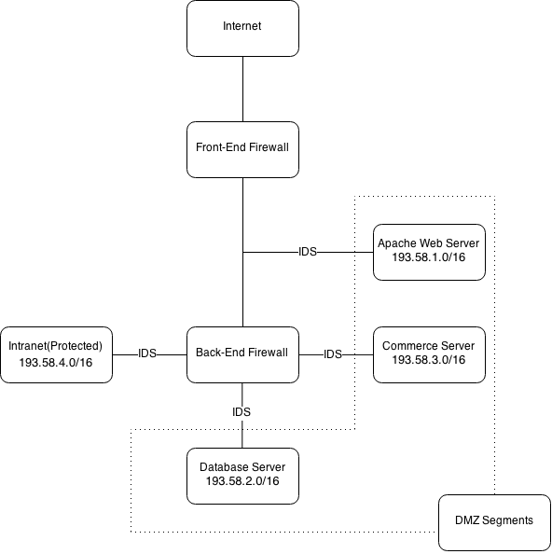

Pseudo-Code Rule set for E-Commerce Network Front-End Firewall  
  
#DMZ (Apache Web Server) Network is 193.58.1.0/16  
#Database Network is 193.58.2.0/16  
#Commerce Server Network is 193.58.3.0/16  
#Intranet (Protected Network) is 193.58.4.0/16  
  
#Format is as follows:  
#Allow or Deny, Source Address, Source Port, Destination Address, Destination Port  
  
#Allow traffic to Apache Web Server  
allow, any, any, 193.58.1.0/16, any

#Deny traffic to Intranet, Database and Commerce Networks

deny, any, any, 193.58.2.0/16, any

deny, any, any, 193.58.3.0/16, any

deny, any, any, 193.58.4.0/16, any

#Allow external (internet) access from Intranet  
allow, 193.58.4.0/16, any, any, any   
  
#Deny all other traffic   
deny, any, any, any, any

Pseudo-Code Rule set for E-Commerce Network Back-End Firewall

#DMZ (Apache Web Server) Network is 193.58.1.0/16  
#Database Network is 193.58.2.0/16  
#Commerce Server Network is 193.58.3.0/16  
#Intranet (Protected Network) is 193.58.4.0/16

#Intranet (Protected Network) Admin user is 193.58.4.1/16

#Intranet (Protected Network) Database Admin user is 193.58.4.2/16  
  
#Format is as follows:  
#Allow or Deny, Source Address, Source Port, Destination Address, Destination Port

#Allow traffic to Apache Web Server from Admin user and all users via SSH, Deny traffic from any other user  
allow, 193.58.4.1/16, any, 193.58.1.0/16, any

allow, 193.58.4.0/16, 22, 193.58.1.0/16, 22

deny, 193.58.4.0/16, any, 193.58.1.0/16, any

#Allow traffic to Database and Commerce Networks from Apache Web Server

allow, 193.58.1.0/16, 2345, 193.58.2.0/16, 2345

allow, 193.58.1.0/16, 2723, 193.58.3.0/16, 2723

#Allow traffic to Database from Intranet Database Admin

allow, 193.58.4.2/16, 3306, 193.58.2.0/16, 3306

#Allow external (internet) access from Intranet  
allow, 193.58.4.0/16, any, any, any  
  
#Deny all other traffic   
deny, any, any, any, any